CARD 12
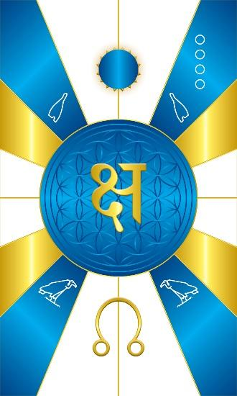
Card 12 is Nekhebet, the electronegative end of the magnetic spectrum or magnet. Its colors are a blueish. In Vedic astrology, it is known as Rahu, the north node of the moon, which is the symbol depicted at the bottom. Structurally, the bottom is Yin, so we position the symbol for Rahu at the bottom to show that it is a yin energy. Nekhebet is a psychic energy that affects the sun/will within you. This is why in Vedic Astrology, Rahu corresponds to a solar eclipse. It eclipses your will. At the top, structurally the solar principle, you see a circular disk obscuring the sun with it’s rays peeking out from behind to show that the solar principle has been eclipsed. In the middle is the Sanskrit letter for the word of power/mantra or sound “Kshang”.

In the upper quadrants we have the white crown of southern Egypt, and in the lower quadrants the symbol for Nekhebet, which is the vulture.

Comments by Baba Awodele

